

Test Cases

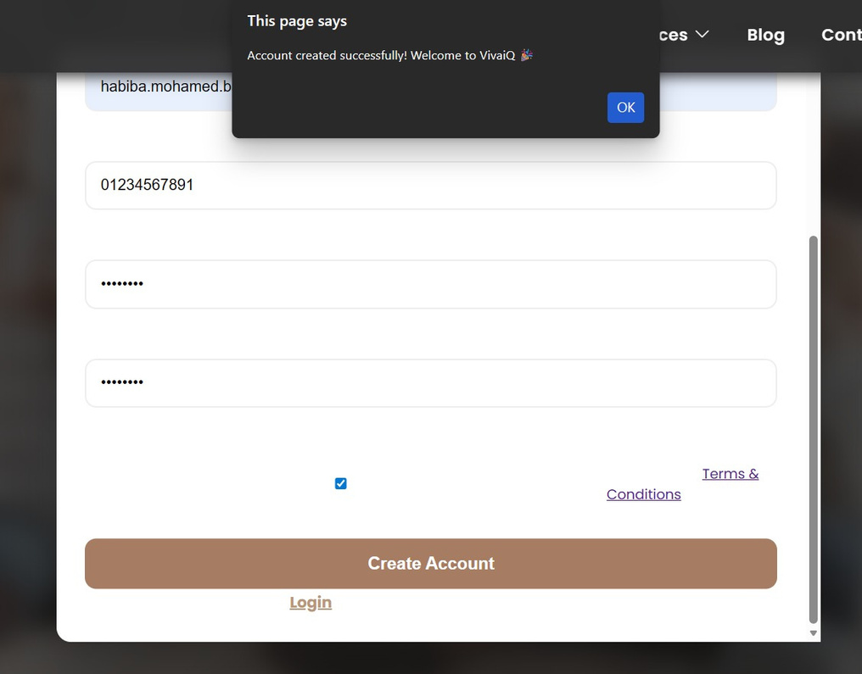
TC_ID | Module | Test Scenario | Test Steps | Test Data | Expected Result
TC_1 | Registration | Verify error for short full name | 1. Open registration page.  2. Enter full name less than 12 characters.  3. Fill other valid data.  4. Submit. | Full name: "Habiba"  Email: boba392005@gmail.com  Phone: +2012067582 | Error: "Full name must be at least 12 characters"

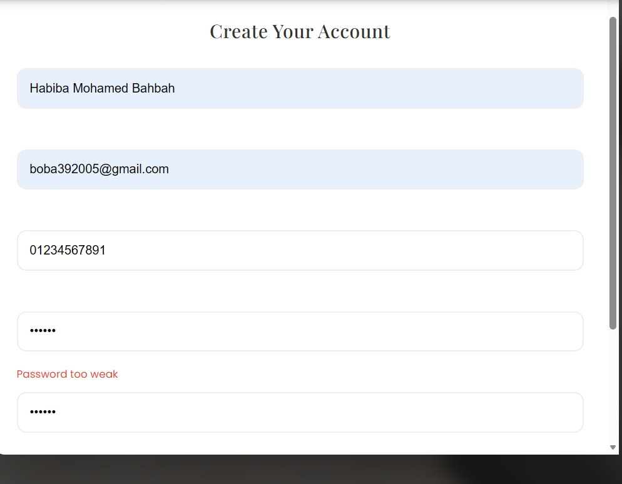

TC_ID | Module | Test Scenario | Test Steps | Test Data | Expected Result
TC_2 | Registration | Verify weak password error | 1. Enter valid name, email, phone.  2. Enter weak password (e.g., 5 chars).  3. Submit. | Password: "*****" | Error: "Password too weak"

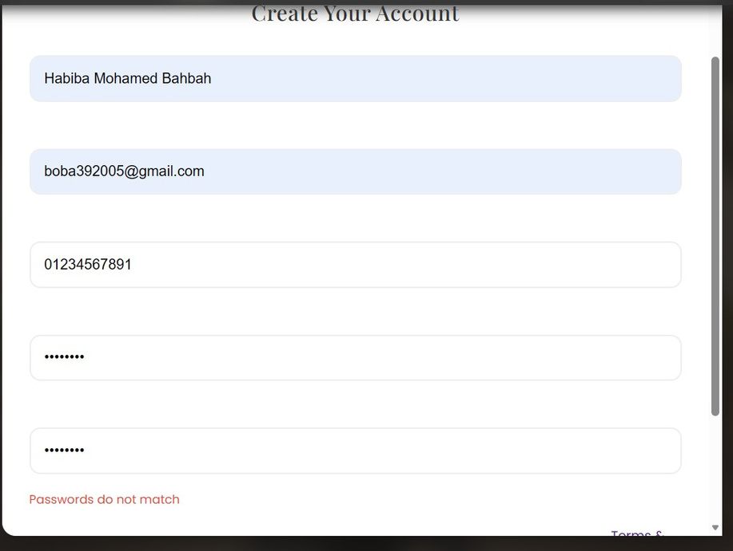
TC ID | Module | Test Scenario | Test Steps | Test Data | Expected Result
TC_3 | Registration | Verify password mismatch error | 1. Enter valid name, email, phone.  2. Enter password and different confirm password.  3. Submit. | Password: **********  Confirm: Different | Error: "Passwords do not match"

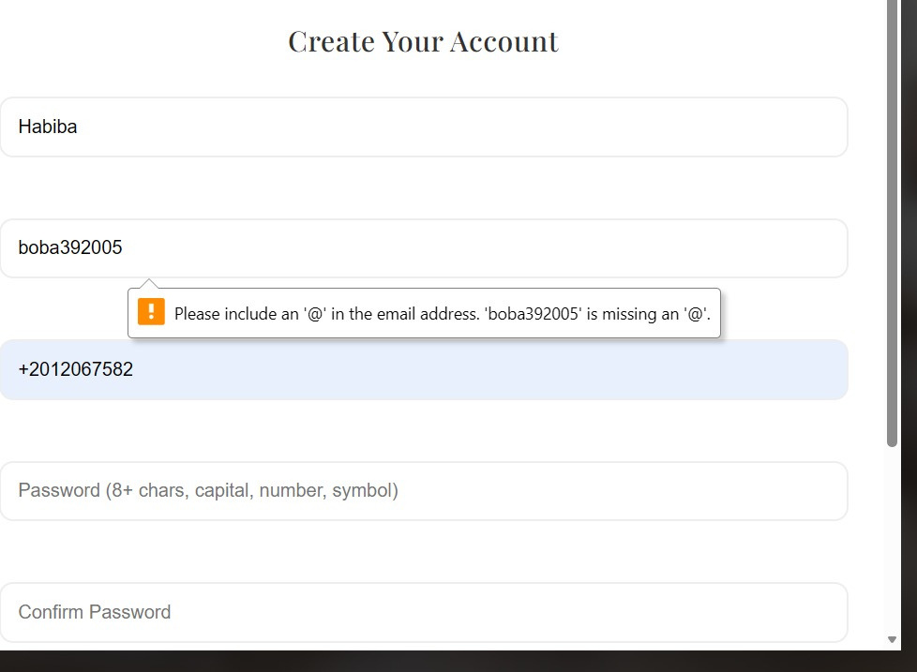

TC_ID | Module | Test Scenario | Test Steps | Test Data | Expected Result
TC_4 | Registration | Verify invalid email error | 1. Enter email without '@'.  2. Fill other fields.  3. Submit | Email: "boba392005" | Error: "Please include an '@'..."

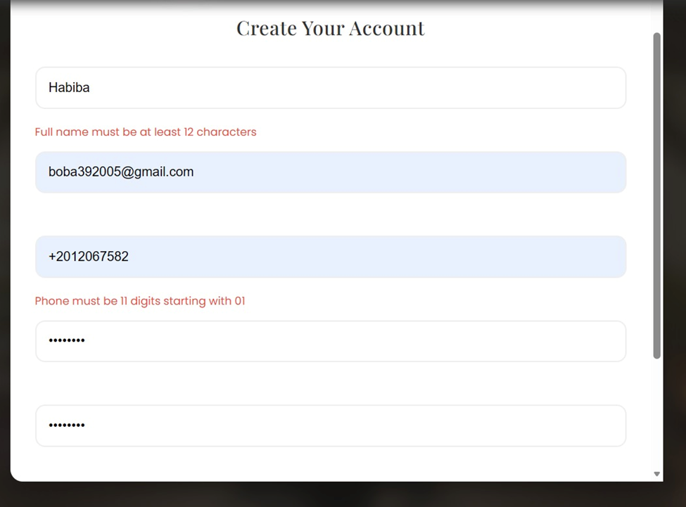
TC_ID | Module | Test Scenario | Test Steps | Test Data | Expected Result
TC_5 | Registration | Successful registration | 1. Enter all valid data.  2. Check T&C.  3. Submit. | Full name: ≥12 chars  Email: valid  Phone: 11 digits, starts 01  Password: Strong  T&C: Checked | Account created, redirect to login
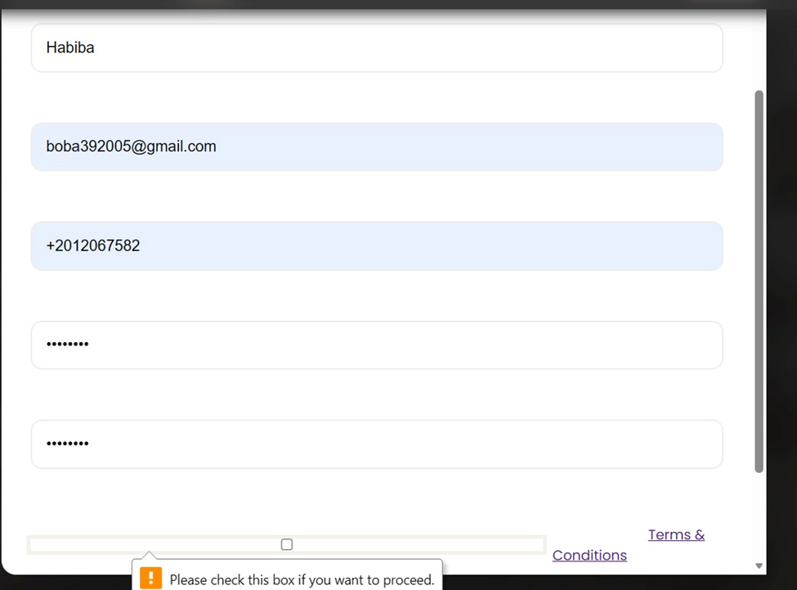
TC_ID | Module | Test Scenario | Test Steps | Test Data | Expected Result
TC_6 | Registration | Verify Terms & Conditions validation | 1. Fill all fields correctly.  2. Do not check T&C box.  3. Submit. | T&C: Unchecked | Error: "Please check this box..."

